

**CIT 0573**

**DATABASE MANAGEMENT SYSTEM**

**PROBLEM BASE LEARNING 1**

**“CAR RENTAL SYSTEM”**

STUDENT NAME : MUHAMMAD IKMAL BIN AZMAN (SET19040080)

: WAN HANI SYAFIAH BINTI WAN RADZI (SET19040025)

TRADE : SEMESTER 3 DSET 2 (JULY 2020)

TTO’S NAME : MISS NORULMUBARAKAH

**Table of Contents**

**Problem Statement** 3

**Introduction** 4

**List of entity** 5

**List of attributes** 5

**ER Diagram (Crow’s Foot)** 6

**Business rules** 7

**Screenshot Table and Relational Schema from Microsoft Access.** 9

**Conclusion** 10

# **Problem Statement**

As people mostly use the manual process to do their rental services, it was not the perfect as they wanted. The client of car rental faced these problems:

1. In order to offer cars for rent through car rental, a car owner normally have to come to the nearest agencies office to register car to be rent out.
2. To rent a car through car rental, a prospective renter who is interested in renting a car need to go to the nearest agencies office to register as a client with the agencies.
3. Cars that provide difficulties to rent out are normally advertised in local or national newspaper. It involves a lot of paper work and consumes time.

The main objectives for this system are:

1. To create a system that will allow car owner to register their cars online for rent.
2. To establish a system that will allow renter to register and rent cars online.
3. To create a system that can advertise cars for rent online.
4. To create a system that will reduce paper work and consumes less time.

# **Introduction**

A car rental, hire car, or car hire agency is a company or business that rents cars to students and working people for short periods of time, usually these rents start from a few hours to a day. It is often arranged by many branches or businesses (which allows user to return a vehicle to a different or designated location), and especially located near collage, university, or busy city. Car rental agencies primarily serve people who require a temporary vehicle, for example, those who do not own their own car, travellers who are out of town, or owners of damaged or destroyed vehicles who are awaiting repair or insurance compensation.

Car rental online system is one of the newly developed systems. It is specializing in Car rental services and other services that are related to either the owner or the renter. This system has been created for the role of car rental to act as an intermediary between two clients, namely the car owner and the renter. Anyone who has the interest to rent will not have to register, he or she can have a full access to this system. This system is here to give the best services to the clients and make ensure they get their things to happen as they wanted.

As the owner of a car, you need to register your car that you want to rent out with the company. During the registration, all the details or information about the car will be fully given. As a renter, you also need to register and then search for the desired car you want to rent and the system will check for available car with the same match.

# **List of entity**

1. Agencies
2. Customers
3. Rentals
4. Vehicles
5. VehicleClasses

# **List of attributes**

1. Agencies

* Agency_ID
* Agency_Location

1. Customers

* Customer_ID
* Customer_Name
* Customer_Address
* Customer_TelephoneNumber
* Agency_ID

1. Rentals

* Rental_ID
* Customer_ID
* Rental_Start_Date
* Rental_Return_Date
* Vehicle_ID
* Agency_ID

1. Vehicles

* Vehicle_ID
* Vehicle_Class_ID
* Rental_ID

1. VehicleClasses

* Vehicle_Class_ID
* Vehicle_Class_Name

# **ER Diagram (Crow’s Foot)**

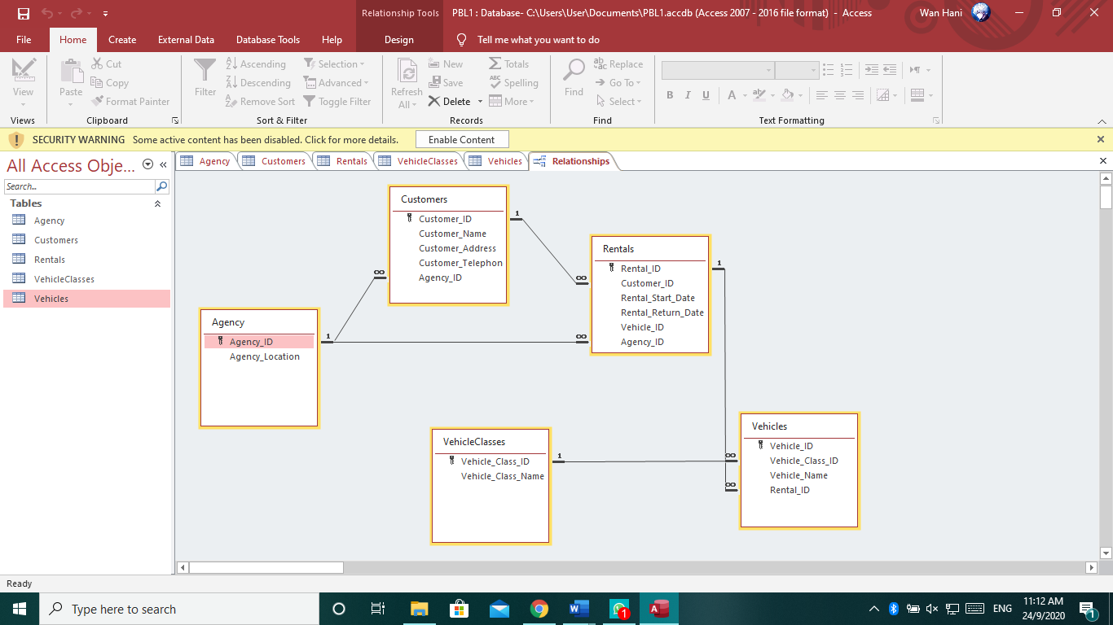

# **Business rules**

1. One To Many (Agency-Customer)

* An agency can appoint many customers, each customer is appointed by one agency

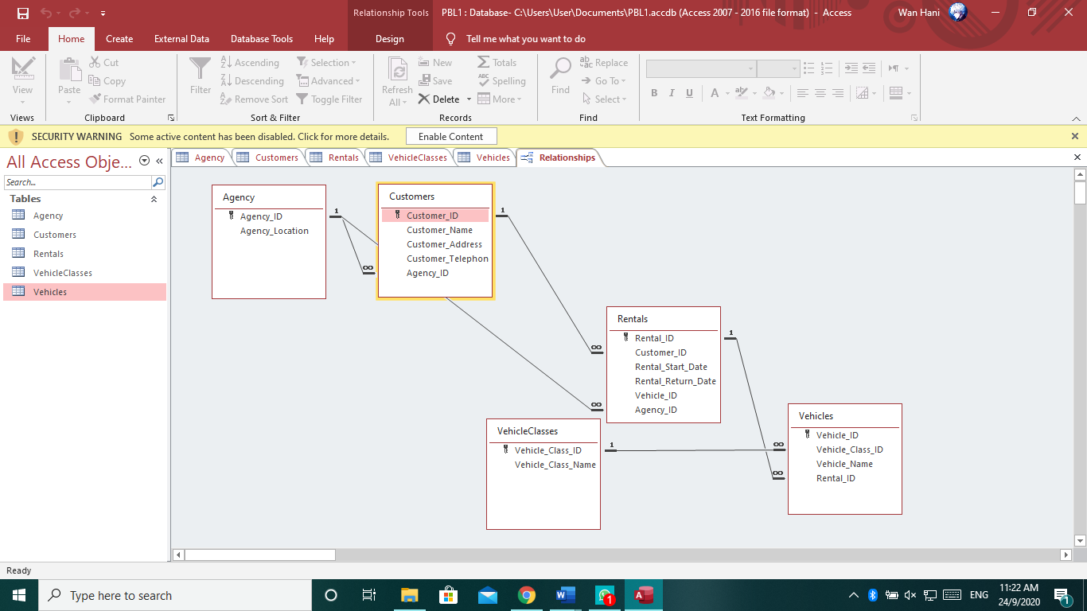

1. One To Many (Agency-Rentals)

* An agency can manage many rentals, each rental is managed by one agency

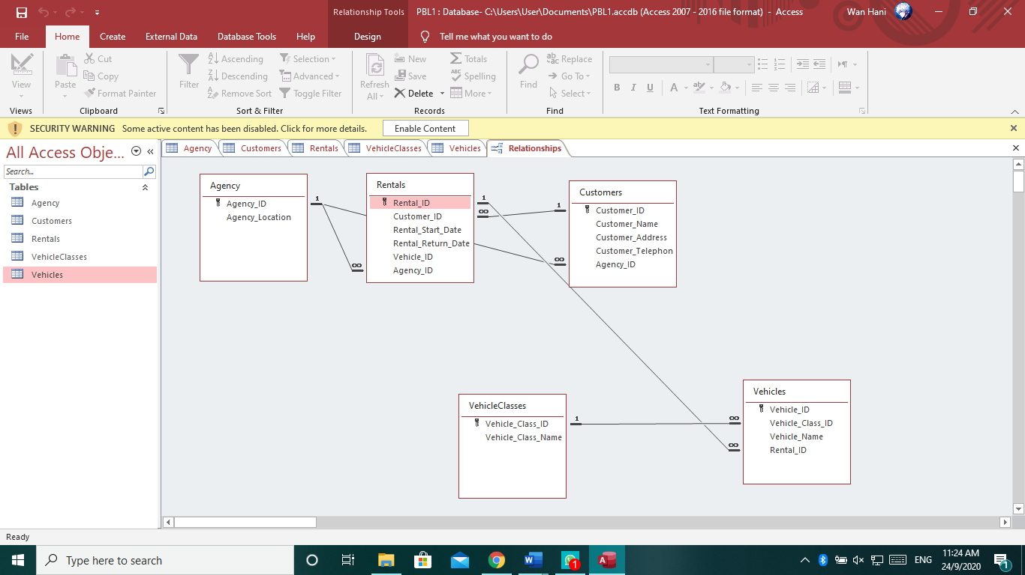

1. One To Many (Customer-Rentals)

* A customer can pay many rentals, each rental is paid by one customer

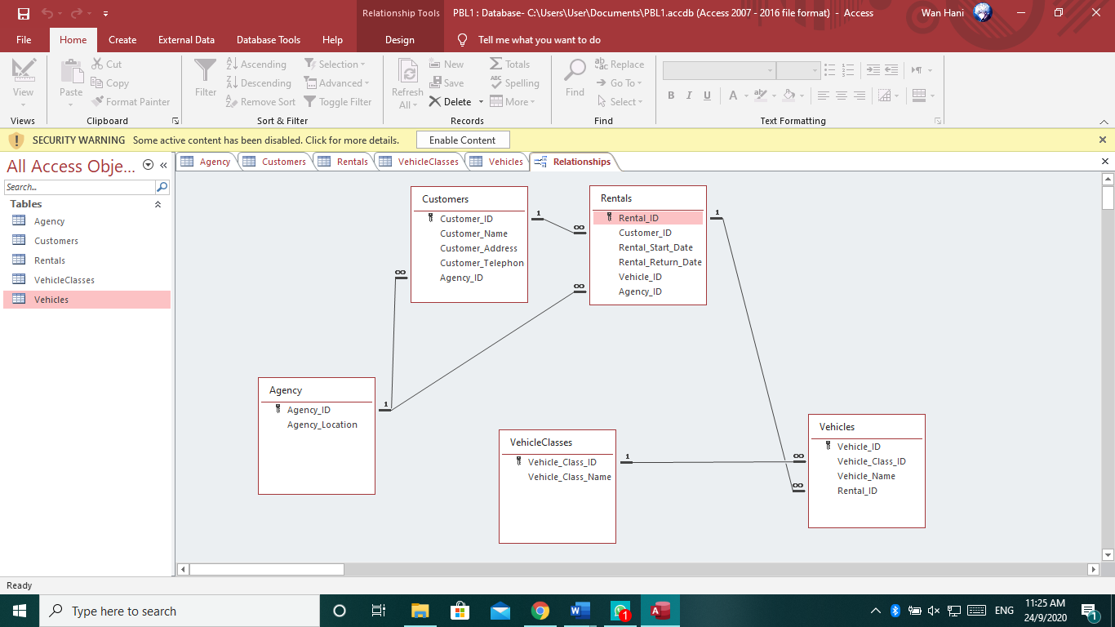

1. One To Many (Rentals-Vehicles)

* A rental can rent many vehicles, each vehicle is rented by one rental

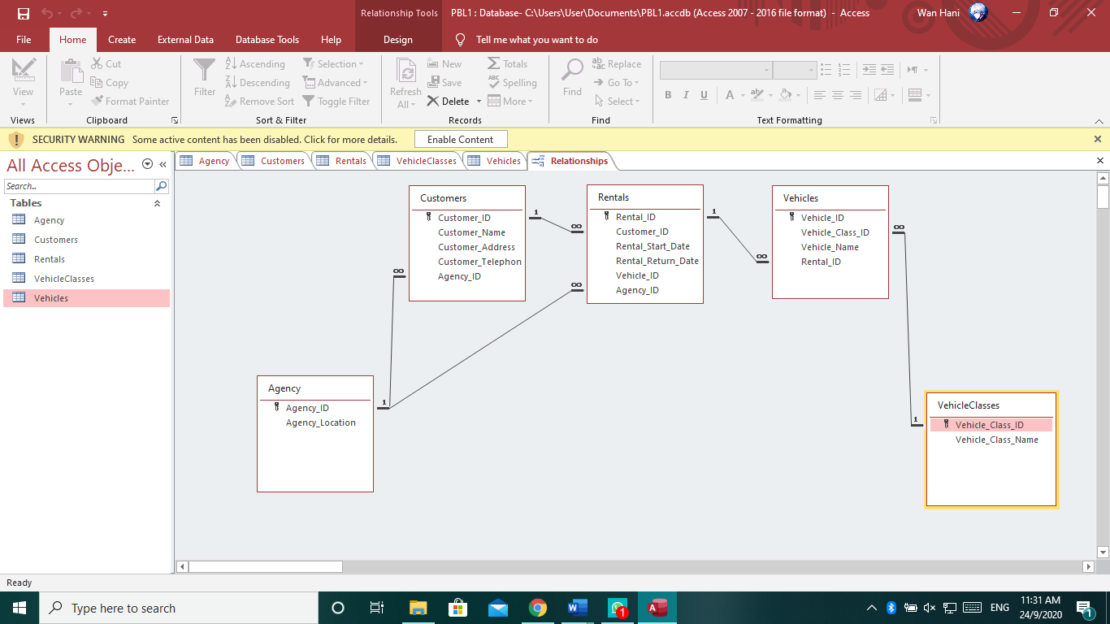

1. One to Many (VehicleClasses - Vehicles)

* A VehiclesClasses can provide many vehicles, each vehicle is provided by one VehicleClasses

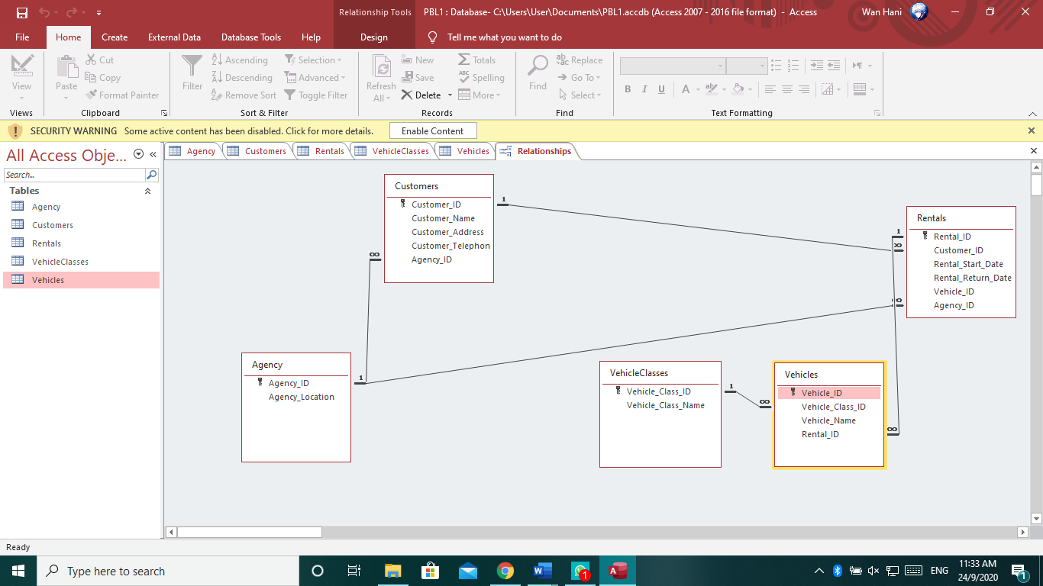

# **Screenshot Table and Relational Schema from Microsoft Access.**

1. **Agency**

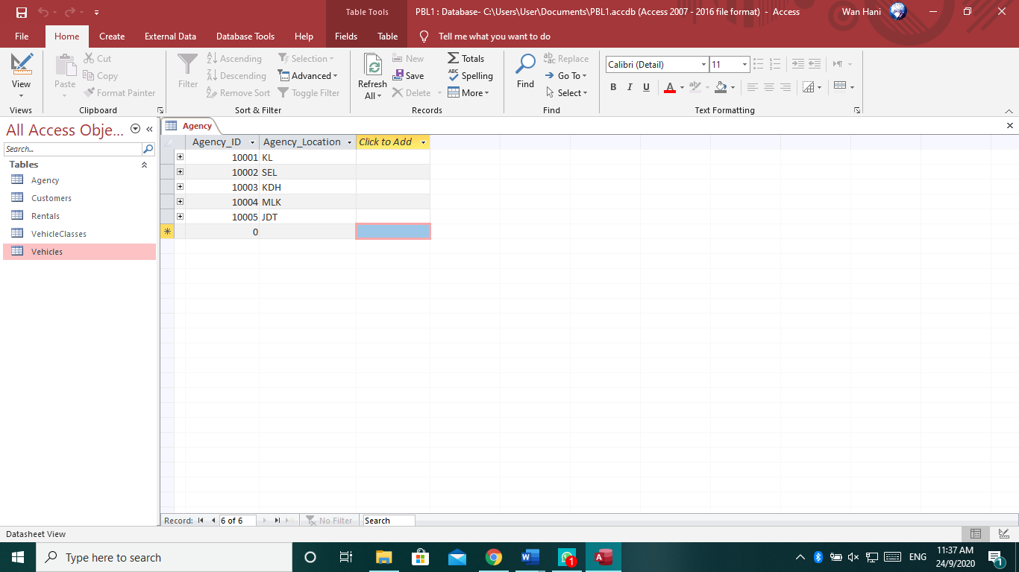

1. **Customers**

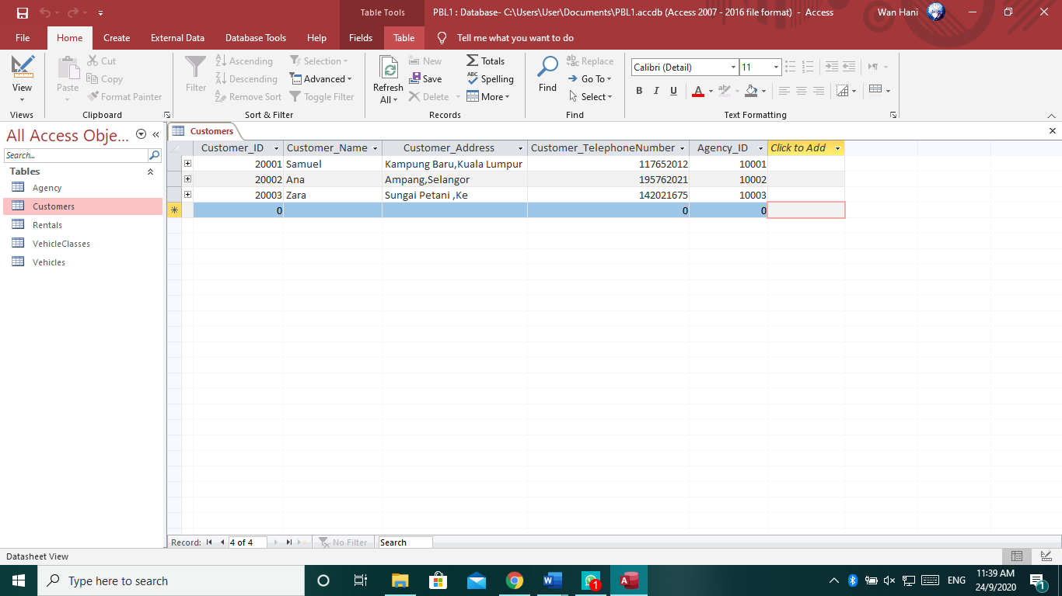

1. **Rentals**

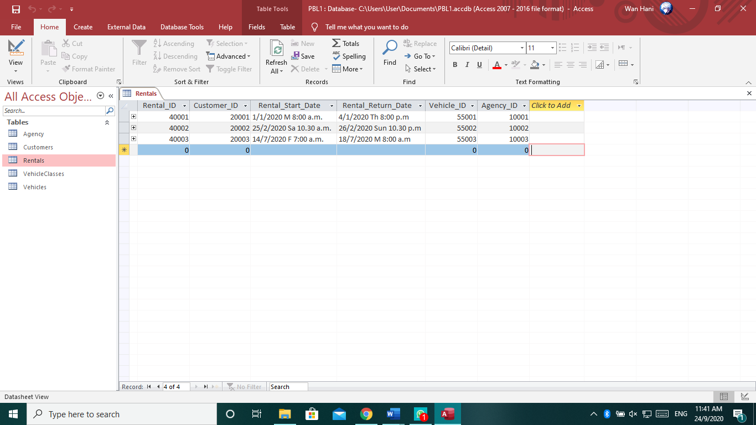

1. **VehicleClasses**

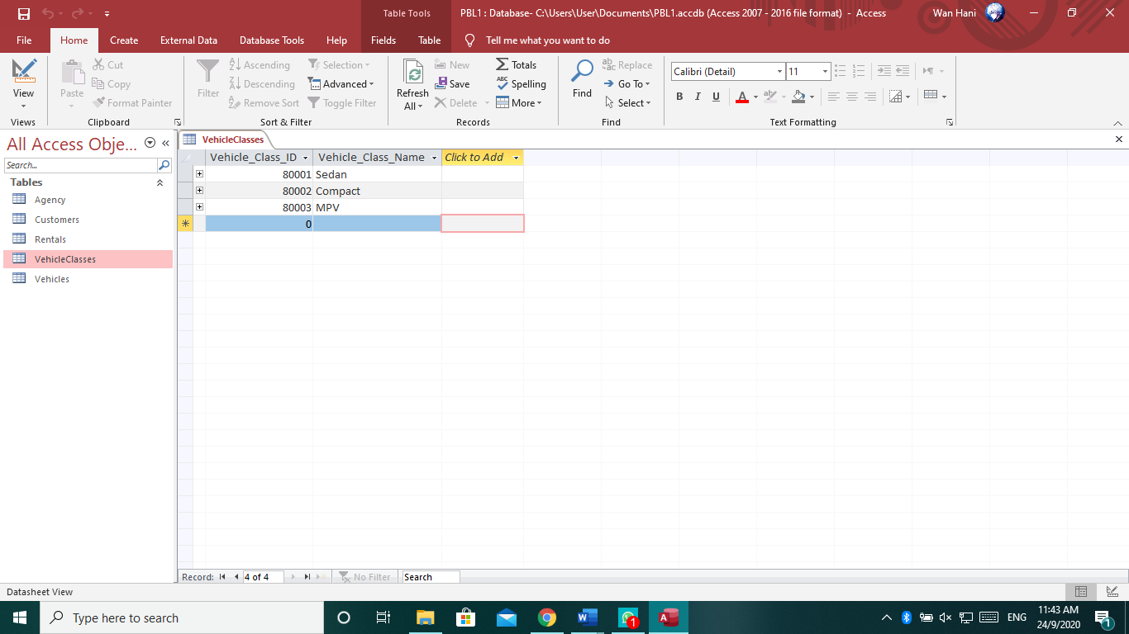

1. **Vehicles**

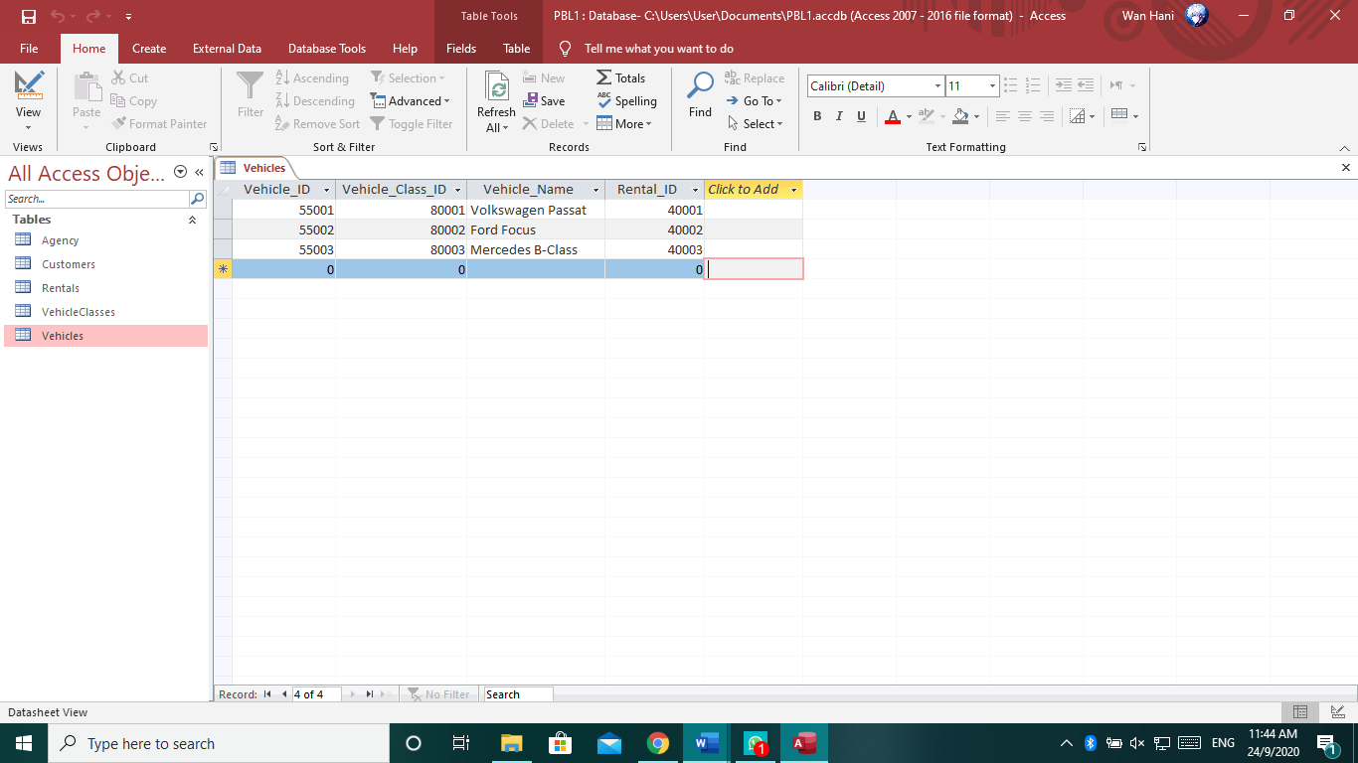

# **Conclusion**

In this conclusion, we know that the car rental system is a company or business that rents cars to students and working people for short periods of time, usually these rents start from a few hours to a day. It is often arranged by many branches or businesses (which allows user to return a vehicle to a different or designated location), and especially located near collage, university, or busy city. The problem that we encountered and need to solve is the in order to offer cars for rent through car rental, a car owner normally have to come to the nearest agencies office to register car to be rent out. To rent a car through car rental, a prospective renter who is interested in renting a car need to go to the nearest agencies office to register as a client with the agencies. Cars that provide difficulties to rent out are normally advertised in local or national newspaper. It involves a lot of paper work and consumes time.

The solution is to create a system that will allow car owner to register their cars online for rent that will allow renter to register and rent cars online. Car rental online system is one of the newly developed systems. It is specializing in Car rental services and other services that are related to either the owner or the renter.